W o o d t u r n e r s of O l y m p I a
Presents : John Jordan & Jack Wayne
Woodturning Symposium : Creativity in Woodturning VI
July 27, 2013 And 4 Work Shops July 28-31, 2013, Lacey, Wa. 98503
Cost : $90.00 until June 01, 2013 then $100.00
Youth under 18yr’s with paying adult $10.00
Symposium Registration & Information @ www.woodturnersofolympia.org

Work Shops : Contact Al Price @ aprice44@aol.com or 360-791-0396
John Jordan
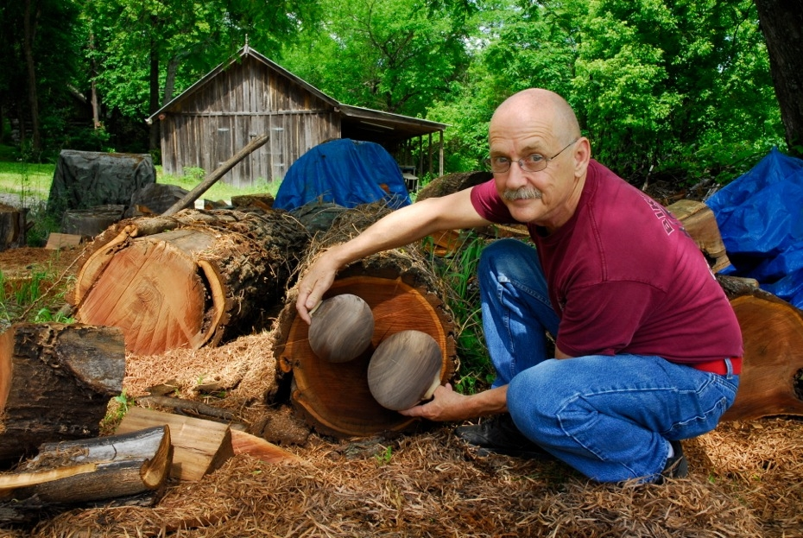
John is famous for his wonderful textured and carved
hollow vessels. His work has received numerous awards,
and are in permanent collections of many museums and
Corporations. His pieces are turned from fresh, green logs,
then hand carved and textured. He will explain how the
Characteristics of wet wood affects the preparation and
outcome of turned pieces as well as hollow form techniques
and surface treatments.
No Refunds after May 31, 2013

2013 Symposium Work Shops
Woodturners of Olympia

One on One Hands on Class with John Jordan

Cost of each class : $150.00ea
8 students in each class // No Refunds after May 31, 2013
2013 Sym. Jordan Work Shop Schedule

WS # 1 Sunday, July 28, 2012 // Bowl Turning

WS # 2 Monday, July 29, 2013 // Turning w/ Carving & Texturing

WS # 3 Tuesday, July 30, 2013 // Tea Pot ( Intermediate Level )

WS # 4 Wednesday, July 31, 2013 // Hollow form or Bowl
For Information and to Reg. Contact AL Price 360-791-0396 or aprice44@aol.com

